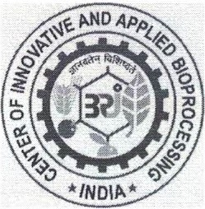
CENTER OF INNOVATIVE AND APPLIED BIOPROCESSI NG (CIAB)
(Department of Biotechnology, Ministry of Science and Technology)
Sector-81 (Knowledge City), PO-Manauli,S.A.S. Nagar, Mohali -140306 (Punjab)

Advt. No: CIAB/52/2020-Rectt .& CIAB/57/2021 -Rectt.

Sr.  No. | Name of the Position | Date of | Name of the Selected
 |  | Written Test | · | Candidate (s)
1. | Sr. Technical Assistant (Biochemistry I  Food Science & Technology) | 30-09-2021 | Ms. Sandhya Yadav (Roll No. 300911)

Advt. No: CIAB/57/2021-Rectt.

Sr.  No. | Name of the Position | Date of Written Test | Name of the Selected Candidate (s)
1. | Sr. Technical Assistant,(Microbial and Enzyme Bioprocessing) | 30-09-2021 | Ms. Suvosree Mukherjee (Roll No. 300950)

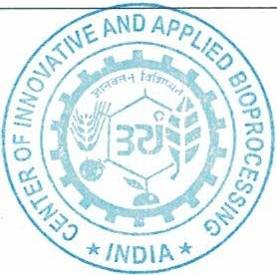-Sd-
Administrative Officer

